[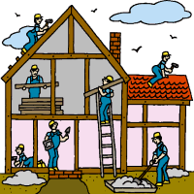](http://www.google.com/url?sa=i&source=images&cd=&cad=rja&docid=t9egI_dVTyCugM&tbnid=wWlM7V7eUKyC9M:&ved=0CAgQjRwwAA&url=http://renovationoptions.ca/own-a-business/&ei=Tb7JUeHAF-a2igLsxIG4Cg&psig=AFQjCNFrOwIg_oXVGtjSfZcmGE7vBiQRaw&ust=1372262349431677)



**Home Renovation: Repairing or Modifying Your Home through an IDA**

Name: Date: __

**Course of Study:**

**Home Renovation: Repairing or Modifying Your Home through an IDA**

**Instructions for Warm Springs community members and WSCAT staff members:**

This course of study is to provide Warm Springs Tribal and community members with an understanding of how to improve, modify, or repair their primary residence using savings from their individual development accounts (IDAs). To complete the course, community members are required to study and gain an understanding of various topics, including maintaining a home, understanding a home’s features, scheduling home maintenance and repairs, prioritizing home repairs, and avoiding problems with contractors. There are several required readings for the course, which are listed at the bottom of this page.

**Goal:**

To facilitate within participants a better understanding of how to assess problems with their homes, select appropriate contractors to renovate or repair problems, budget the appropriate costs for renovation, and avoid remodeling, repair, or construction problems.

**Objectives:**

1. To provide participants with a clear understanding of their home’s features, and of how to maintain their home, and how to prioritize repairs.

2. To provide participants the opportunity to reflect on what type of renovation they would like to do, and how it would benefit their living situations.

3. To provide participants with the knowledge it takes to select a contractor, to avoid remodeling, repair, and construction problems.

4. To enable participants to determine the cost of their renovation, to consider the extent to which the savings in their IDA account will pay for the renovation, and to consider other means of financing the renovation.

**Time Required:**  8 hours.

**Required Reading:**

Pathways Home: A Native Homeownership Guide, Module 8

* 1. Pg. 12-20. Topics: Maintaining your home, understanding your home’s features, scheduling home maintenance and repairs, prioritizing home repairs, home improvements.
  2. Appendix B, Baseline Condition of Home Features, pg. 39-40
  3. Appendix C, Item Useful Life, pg. 41-44
  4. Appendix D, Seasonal Maintenance Planner, p. 45-48.

“Home Sweet Home… Improvement,” US Federal Trade Commission Consumer Information Page, August 2001: <http://www.consumer.ftc.gov/articles/0242-hiring-contractor>

“16 Ways to Avoid Remodeling, Repair, and Construction Problems,” State of Oregon Construction Contractors Board, Revised February 2010: <http://ccbed.ccb.state.or.us/WebPDF/CCB/Publications/16-ways.pdf>

[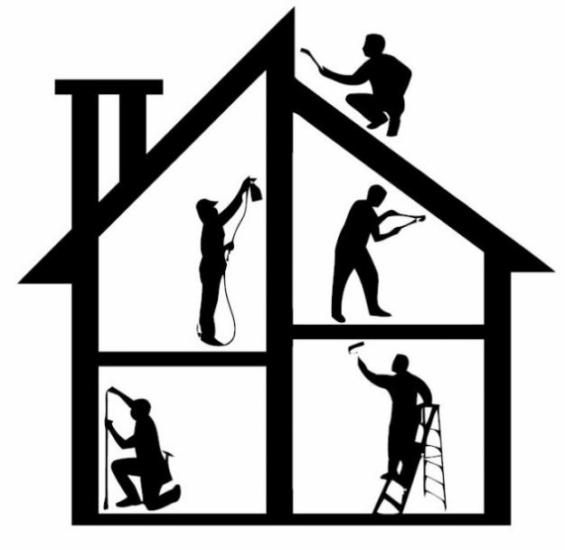](http://www.google.com/url?sa=i&source=images&cd=&cad=rja&docid=w51_TH0kPmP-lM&tbnid=iqRhDY6NdOAQxM:&ved=0CAgQjRwwAA&url=http://clearcorpsdetroit.org/resources/home-repair-resources/&ei=9H7LUf7XOozBiwLArYCgCQ&psig=AFQjCNHMABSoAtxuJebrAlfOwG0svsHRIA&ust=1372377205001213)Part 1: Understanding your home’s features

Time required: 2 hours

1. Please read pg. 12-20 of the Pathways Home: A Native Homeownership Guide, Module 8, on maintaining your home, understanding your home’s features, scheduling home maintenance and repairs, prioritizing home repairs, and home improvements.

Assignments:

1. Complete the exercise on pg. 19 (prioritizing home repairs)
2. Answer questions on the bottom of pg. 20 (doing the work yourself)
3. Discuss exercises and questions on pg. 19-20 with WSCAT staff
4. Please review Appendix B, pg. 39-40, Baseline Condition, and consider the condition of the various exterior and interior systems and features of your home.
5. After reviewing Appendix B, did you find any unexpected conditions in need of maintenance or repair?

________________________________________________________________________________________________________________________________________________________________________________________________________________________________________________________________________________________________________________________________________________________________________________________________________________________________________________________________________________________________________________________________________________________________________________________________________________________

1. In your home, do you have any of the following types of damage?
   1. Water □ No □ Yes
   2. Foundation □ No □ Yes
   3. Electric □ No □ Yes
   4. Mold □ No □ Yes
   5. Septic □ No □ Yes
   6. Other: ____________ □ No □ Yes
   7. Other: ____________ □ No □ Yes
2. Do you need repairs or modifications to?
   1. Drainage □ No □ Yes
   2. Roof □ No □ Yes
   3. Insulation □ No □ Yes
   4. Heating system □ No □ Yes
   5. Energy efficiency □ No □ Yes
   6. Plumbing □ No □ Yes
   7. Other: ____________ □ No □ Yes
   8. Other: ____________ □ No □ Yes
3. Please review Appendix C, pg. 41-44, Item Useful Life, and consider the lifespan of the various exterior and interior features of your home.
4. After reviewing Appendix C, what new insight (if any) did you gain on the useful life of various items in your house? After going through the list, did you think about which items may need to be replaced next? Is there anything that needs to be replaced soon or immediately?

________________________________________________________________________________________________________________________________________________________________________________________________________________________________________________________________________________________________________________________________________________________________________________________________________________________________________________________________________________________________________________________________________________________________________________________________________________________________________________________________________________

D. Please review Appendix D, Seasonal Maintenance Planner.

1. Each year, do you systematically plan, based on seasonal or other criteria, when to undertake home improvement projects?

□ No □ Yes

1. Is it a good idea to do this? Why or why not?

________________________________________________________________________________________________________________________________________________________________________________________________________________________________________________________________________________________________________________________________________________________________________________________________________________________________________________________________________________________________________________________________________________________________________________________________________________________

[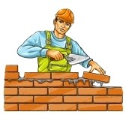](http://www.google.com/url?sa=i&rct=j&q=&esrc=s&frm=1&source=images&cd=&cad=rja&docid=MCzuQVq78I51WM&tbnid=hfruo3eQbslzAM:&ved=0CAUQjRw&url=http://www.123rf.com/photo_5184236_road-builder-man-character-isolated--vector-illustration.html&ei=ZHLMUbSvIeWgiALJiIDQBw&bvm=bv.48572450,d.cGE&psig=AFQjCNF3nBV11z1V8Enoll8yBym2P93Fug&ust=1372439419871917)Part 2: What do you want to do?

Time required: 1 hour

* + 1. Planning your renovation, repair, or modification

*Please answer the following questions:*

1. What renovation, repair, or modification are you planning to complete?

___________________________________________________________________________________________________________________________________________________________________________________________________________________________________________________________________________________________________________________________________________________________________________________________________________________________________________________________________________________________________________________________________________________________________________________________________________________________________________________________________________________________________

1. Are there other home repairs, improvements, or modifications you are considering?

□ No □ Yes Please describe: ___________________________________________________________________________________________________________________________________________________________________________________________________________________________________________________________________________________________________________________________________________________________________________________________________________________________________________________________________________________________________________________________________________________________________________________________________________________________________________________________________________________________________

1. How will the renovation you are planning improve your living situation? (Safety, basic necessity, overcrowding, etc.)

___________________________________________________________________________________________________________________________________________________________________________________________________________________________________________________________________________________________________________________________________________________________________________________________________________________________________________________________________________________________________________________________________________________________________________________________________________________________________________________________________________________________________

[](http://www.google.com/imgres?start=213&sa=X&rlz=1T4ADRA_enUS495US495&biw=1293&bih=592&tbm=isch&tbnid=ABL8gNq4DWcqTM:&imgrefurl=http://www.scamraiders.com/profiles/blogs/unlicensed-contractors-fools&docid=5gLkWniLWhwhzM&imgurl=http://api.ning.com/files/DX59dJlLQUWBQddY0sU4TCCjfB7WL7m4VbjwbUZWZ-X2LWLSdUx2hxiT*7hCq7AevXqCPy3-4ZhiHNK8jQda4eqs7AiqRS*U/21987ClipartPictureIllustrationOfAnOrangeManContractorOrArchitectHoldingRolledBlueprintsAndDesignsAndWearingAHardhat.jpg?width=142&w=142&h=178&ei=wn3MUcn4F-P9igLmt4GQDw&zoom=1&ved=1t:3588,r:22,s:200,i:70&iact=rc&page=10&tbnh=142&tbnw=113&ndsp=20&tx=29&ty=45)Part 3: Selecting a vendor

Time required: 3 hours

A. Comparison shopping: Choosing the right vendor. (3-4 hours)

1. What labor will be required to complete the renovation?

___________________________________________________________________________________________________________________________________________________________________________________________________________________________

1. What equipment and materials be required to complete the renovation?

________________________________________________________________________________________________________________________________________________________________________________________________________________________

1. Please open the following 2 links and read the articles on choosing a home improvement contractor:

* “Home Sweet Home… Improvement,” US Federal Trade Commission Consumer Information Page, August 2001: <http://www.consumer.ftc.gov/articles/0242-hiring-contractor>
* “16 Ways to Avoid Remodeling, Repair, and Construction Problems,” State of Oregon Construction Contractors Board, Revised February 2010: <http://ccbed.ccb.state.or.us/WebPDF/CCB/Publications/16-ways.pdf>

1. Develop a list of potential contractors by talking to friends, family, or others you trust, and by doing appropriate Internet research. Using the above articles and the table below, develop criteria for selecting a contractor. At a minimum, please identify 3 contractors who could possibly perform your renovation, modification, or repair. Please complete the table below, or on a separate sheet of paper:



1. Which company would you like to work with and why? (Lowest price, local, have had previous work done by this company)

________________________________________________________________________________________________________________________________________________________________________________________________________________________________________________________________________________________________________________________________________________________________________________________________________________________________________________________________________________________________________________________________________________________________________________________________________________________________________________________________________________________________________________________________________________

[](http://www.google.com/imgres?imgurl=http://web.dsbn.edu.on.ca/~AnnMarie.DiLibero@dsbn.edu.on.ca/S03D39770-03D39770.4/money.jpg&imgrefurl=http://web.dsbn.edu.on.ca/~AnnMarie.DiLibero@dsbn.edu.on.ca/?OpenItemURL=S03D39770-03D39770&h=350&w=253&sz=28&tbnid=-FUQE8gxzQfscM:&tbnh=90&tbnw=65&zoom=1&usg=__wWsBStoUmecnhpZ2lq_jDLA8uJY=&docid=jgjb4O35jpc3hM&sa=X&ei=K3HMUbnvB-TbigL00oH4Cw&ved=0CD0Q9QEwBA&dur=1254)Part 4: Financing

Time required: 2 hours

1. Financing Your Renovation

*Please answer the following questions and complete the following tasks:*

1. How much do you think the renovation, including labor, equipment rental, materials, and other expenses, will cost?

_________________________________________________________________________________________________________________________________________________________________________________________________________________________________

1. Before completing a home renovation, you must first receive estimates (at least two) for the materials, labor, and other costs involved. Estimates cannot be from an immediate family member or someone who lives in your home. ***Please attach estimates from at least two contractors.*** You must receive approval from a WSCAT IDA program staff member in order to utilize your IDA funds for the purchase:
2. Will you need financing, or will the amount you save in your IDA be enough for the project?

_________________________________________________________________________________________________________________________________________________________________________________________________________________________________

1. If you will need financing, have you researched financing options? □ No □ Yes Please describe:

_____________________________________________________________________________________________________________________________________________________________________________________________________________________________________________________________________________________________________________________________________________________________________________________________________________________________________________________________________________________________________________________________________________